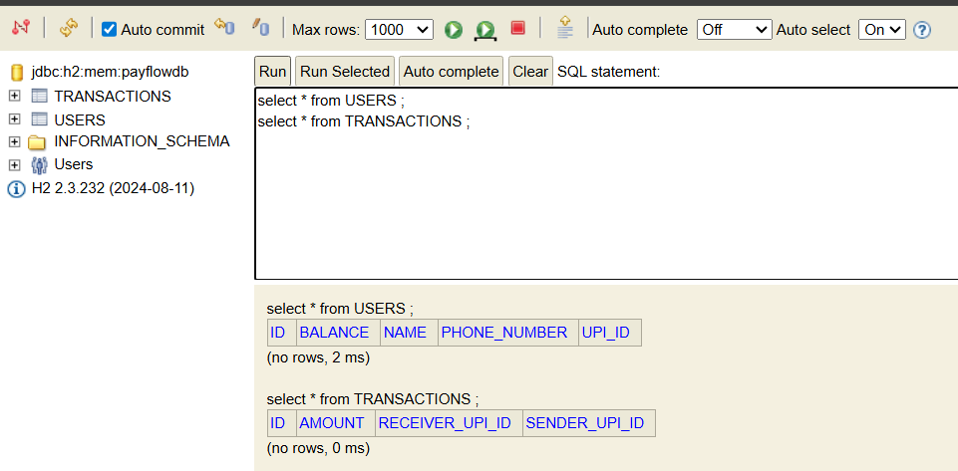
- Screenshot of both tables before inserting any data

- Request Lifecycle
When a client sends a request like POST /users, the request first reaches the embedded Tomcat server running inside the Spring Boot application. Tomcat forwards the request to Spring MVC’s DispatcherServlet, which acts as the front controller for all incoming requests. The DispatcherServlet uses HandlerMapping to find the correct controller method and then calls it using the HandlerAdapter. After the createUser method executes, the response is converted into JSON and sent back to the client.

- Serialization
When a JSON payload such as:
{
"name":"Priya",
"upiId":"priya@okaxis"
}
is sent to the API, Spring Boot uses Jackson’s ObjectMapper to convert the JSON into a Java User object automatically. This process is called deserialization. If the JSON key is written as upi_id instead of upiId, Spring may not map the value correctly because the field name does not match the Java property name. In such cases, annotations like @JsonProperty can be used to define custom mappings.

Spring Boot Features
Spring Boot provides three important features: embedded server, auto-configuration, and production-ready defaults.
In this project, the embedded Tomcat server allowed the application to run directly without installing an external server. Auto-configuration automatically set up components like Hibernate, H2 database, DispatcherServlet, and DataSource based on the dependencies added in pom.xml. Production-ready defaults helped by automatically configuring JSON conversion, dependency injection, error handling, and sensible application settings with very little manual configuration.

Spring vs Spring Boot
If plain Spring had been used instead of Spring Boot, many configurations would have needed to be done manually. This includes setting up the Tomcat server, DispatcherServlet, Hibernate configuration, DataSource configuration, dependency management, and XML or Java-based bean configuration. Spring Boot simplified all of this using starter dependencies and auto-configuration. It automatically configured the project based on the libraries added to the application.

Stateless REST
Stateless means that the server does not store information about previous client requests. Every request must contain all the data required to process it independently. This is important because if PayFlow runs on multiple servers behind a load balancer, any server should be able to handle any request without depending on session data stored in another server. Stateless APIs improve scalability, reliability, and load balancing in distributed systems.

Persistence
Transactions were stored in the H2 database instead of a Java List because data inside a List exists only in application memory temporarily. If the server restarts, all the transaction data stored in memory would be lost permanently. Databases provide persistent storage, meaning the records remain saved even after application shutdown or restart. In a payments application, losing transaction history would be unacceptable because financial systems require reliable and permanent data storage.

SCREENSHOT
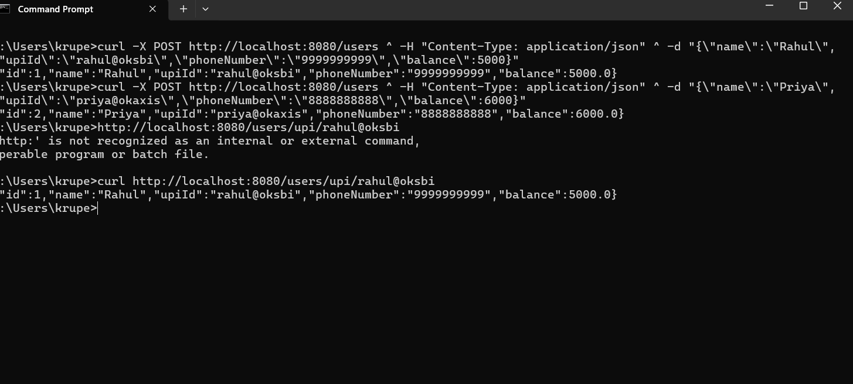

- After inserting users in DB
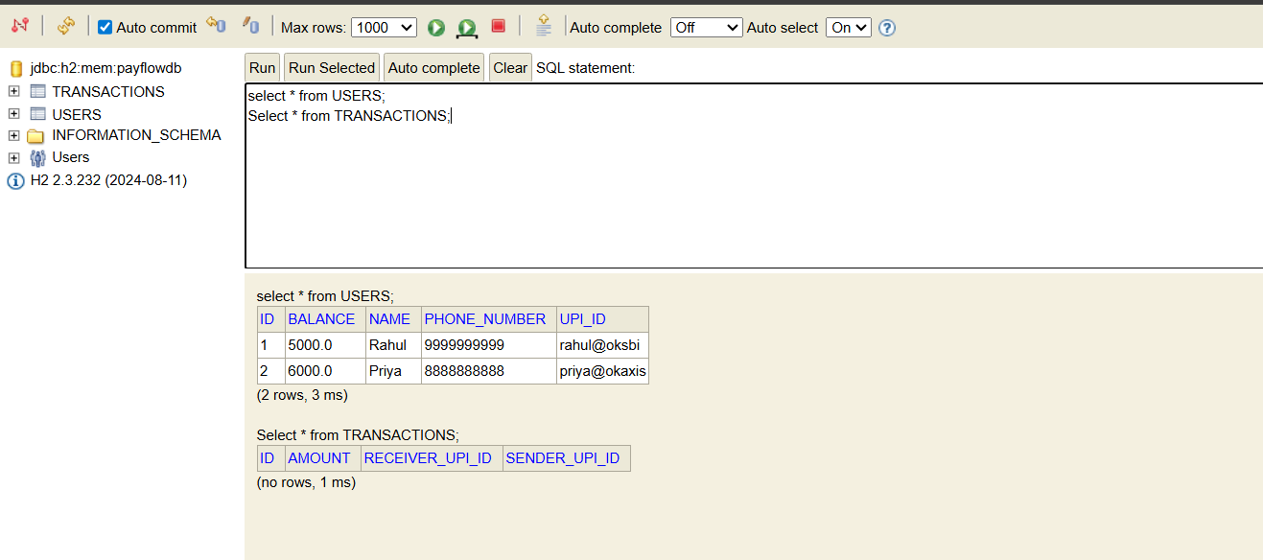

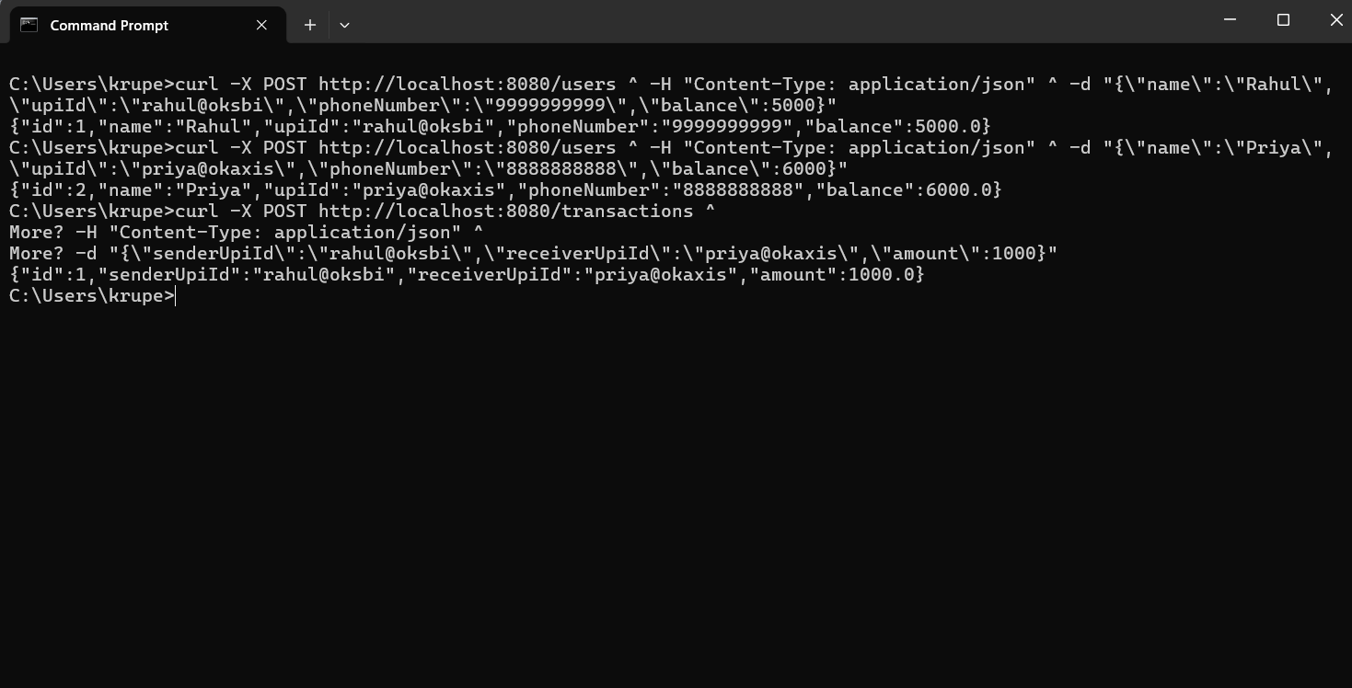

- After calling transactions API
